# FULL STACK DEVOLOPMENT WITH MERN

## PROJECT DOCUMENTATION

# **1. Introduction**

**Project Title:**

## Book Nest : Where Stories Nestle

**Team Members:**

**BATTALA TAGORE**

Book Nest is a full-stack web application developed using the MERN stack (MongoDB, Express.js, React.js, and Node.js). The project is designed to simulate the real-world functionality of an online book shopping platform. It provides a seamless interface for users to browse, purchase, and review books while enabling sellers to manage inventory and orders. Additionally, the admin has full control over users, sellers, books, and system data.

The platform supports three major roles:

* **User:** Can register, browse books, place orders, view order history, give reviews, and manage their profile.
* **Seller (Organizer):** Can manage inventory, add/edit/delete books, view orders, and update statuses.
* **Admin:** Can oversee users, sellers, books, and transactions to ensure smooth platform functioning.

Book Nest was built to understand and apply full-stack web development principles and simulate real-time e-commerce functionalities with authentication, database relationships, secure data handling, and a responsive frontend interface.

The application serves as a comprehensive learning and practical tool for mastering MERN stack development, with a focus on modular architecture, real-world database design (including many-to-many and one-to-many relationships), and third-party integrations such as payment gateways and shipping APIs.

**2. Project Overview**

**Purpose:**

The primary goal of **Book Nest** is to provide a user-friendly online bookstore platform that connects readers with sellers in a digital marketplace. It allows users to explore a wide range of books, make secure purchases, track orders, and share reviews. Sellers can efficiently manage their inventory, orders, and customer interactions. Admins have complete control to manage and monitor platform activity, ensuring smooth operations.

Book Nest also serves as a full-stack development project built using the MERN (MongoDB, Express.js, React.js, Node.js) stack to demonstrate how modern web applications are structured, deployed, and scaled with real-world features like user authentication, role-based access control, and dynamic UI rendering.

**Features:**

🔹 **User Features:**

* User registration, login, and profile management
* Browse books by category, genre, author, or search
* Add books to wish list or cart
* Place and track orders
* Leave reviews and ratings
* View booking/order history

🔹 **Seller (Organizer) Features:**

* Seller registration and login
* Manage personal profile and dashboard
* Add new books with title, author, price, stock, image, genre
* Update or delete books from the inventory
* View and fulfil orders placed by users

🔹 **Admin Features:**

* Admin login and full platform access
* Manage users, sellers, books, orders, and reviews
* Generate reports or analytics (optional)
* Remove inappropriate content or suspend users/sellers if needed

🔹 **Technical Features:**

* Role-based access control (User, Seller, Admin)
* JWT-based authentication and session management
* MongoDB schemas with many-to-many and one-to-many relationships
* RESTful APIs for all major operations
* Responsive and dynamic frontend using React and Bootstrap
* Integration with third-party APIs for payments or logistics (optional/future enhancement)

**3. Architecture**

The **Book Nest** project follows the MERN stack architecture, which separates the application into three main layers: **Frontend (React)**, **Backend (Node.js & Express.js)**, and **Database (MongoDB)**. This modular structure enhances scalability, maintainability, and separation of concerns.

**Frontend:**

* **Framework:** React.js
* **Libraries Used:** React Router DOM (for routing), Axios (for API calls), Bootstrap/React-Bootstrap (for UI design)
* **Responsibilities:**
  + Displays the user interface for Users, Sellers, and Admin
  + Handles routing between pages (e.g., Home, Books, Cart, Login, Dashboard)
  + Interacts with the backend through API calls using Axios
  + Manages user sessions via tokens stored in localStorage
  + Dynamic rendering based on roles (e.g., show/hide seller/admin dashboards)

**Backend:**

* **Runtime & Framework:** Node.js with Express.js
* **Responsibilities:**
  + Handles all API requests for users, books, orders, reviews, and authentication
  + Implements business logic for different roles (User, Seller, Admin)
  + Validates data, processes orders, manages user sessions
  + Middleware used for authentication, error handling, and request logging
  + Ensures secure data transfer between client and server using tokens (JWT)

**Database:**

* **Database:** MongoDB (NoSQL)
* **ODM:** Mongoose
* **Schema Design:**
  + **User Schema** – stores user credentials, role (User/Seller/Admin), profile info, wish list, and order history
  + **Book Schema** – includes title, author, genre, price, stock, seller ID (ref), reviews
  + **Order Schema** – includes user ID, book list, order status, payment details
  + **Review Schema** – stores rating, comment, user ID (ref), and book ID (ref)
  + **Inventory Management** – one-to-many relationship between Seller and Books
  + **Many-to-Many Relationships:** Book–Genre, Book–Author, User–Book (wishlist), Book–Review

**Flow of Architecture:**

1. **User Interaction:** User accesses the React frontend to browse and interact with books.
2. **API Requests:** React frontend sends HTTP requests to Express backend.
3. **Data Processing:** Backend authenticates and processes logic using controllers and services.
4. **Database Communication:** Backend communicates with MongoDB using Mongoose models.
5. **Response:** Backend sends response back to frontend (e.g., book list, order confirmation).
6. **Rendering:** React updates UI based on the received data and user role.

**4. Setup Instructions**

This section outlines the prerequisites and step-by-step process to set up the BookNest project on a local development environment.

**Prerequisites**

Before setting up the project, ensure the following software and tools are installed on your system:

* [Node.js](https://nodejs.org/) (v16 or above)
* [MongoDB](https://www.mongodb.com/) (Local or MongoDB Atlas)
* [Git](https://git-scm.com/) (for cloning the project)
* Code Editor (e.g., [VS Code](https://code.visualstudio.com/))
* Terminal or Command Prompt

**Installation**

**Step 1: Clone the Repository**

bash

git clone https://github.com/your-username/booknest.git

cd book nest

**Step 2: Set Up the Backend**

cd server

npm install

* Create a .env file in the server directory and add the following variables:

PORT=5000

MONGO_URI=your_mongodb_connection_string

JWT_SECRET=your_jwt_secret_key

*Use* [*MongoDB Atlas*](https://www.mongodb.com/cloud/atlas) *or local MongoDB and paste the correct URI.*

**Step 3: Set Up the Frontend**

cd client

npm install

* Update the proxy field in client/package.json to match your backend server:

"proxy": "http://localhost:5000"

**Step 4: Run the Application**

* **Start Backend:**

cd server

npm start

* **Start Frontend:**

cd client

npm start

**Step 5: Access the Application**

* Open your browser and go to:  
  👉 http://localhost:3000 – React frontend  
  👉 http://localhost:5000/api – Backend API endpoints

**5. Folder Structure**

The **Book Nest** project is divided into two main parts: the **client** (frontend) and the **server** (backend). Each part has its own organized folder structure to maintain clarity and modularity.

**Client (Frontend)**

Path: /client

This directory contains the React frontend built with functional components, routing, and API integration.

client/

│

├── public/ # Public assets like index.html, favicon

│

├── src/ # React source files

│ ├── assets/ # Images, logos, and other static files

│ ├── components/ # Reusable UI components (Navbar, Book Card, etc.)

│ ├── pages/ # Page-level components (Login, Home, Book Details, etc.)

│ ├── services/ # Axios API functions

│ ├── context/ # React context for auth/user state

│ ├── App.js # Root component with routes

│ └── index.js # Entry point for React app

│

├── package.json # Frontend dependencies and scripts

└── README.md

**Server (Backend)**

Path: /server

This directory contains the Node.js backend with Express routing, Mongoose models, and middleware.

server/

│

├── config/ # MongoDB connection and environment config

│

├── controllers/ # Functions handling request logic

│

├── models/ # Mongoose schemas (User, Book, Order, Review, etc.)

│

├── routes/ # Express routes (userRoutes, bookRoutes, orderRoutes)

│

├── middleware/ # Auth middleware, error handlers

│

├── utils/ # Helper functions, token generators

│

├── .env # Environment variables (not committed to Git)

├── server.js # Entry point of the backend

├── package.json # Backend dependencies and scripts

└── README.md

**6. Running the Application**

This section explains how to launch the **Book Nest** application locally after setup is complete.

**Step-by-Step Execution**

**✅ 1. Start MongoDB**

* If you're using **MongoDB Atlas**, ensure your cluster is **online** and the connection string is correctly set in your .env file.
* If you're using **local MongoDB**, start the MongoDB service:

**✅ 2. Start the Backend Server**

Open a terminal and navigate to the server folder:

cd server

npm start

* The backend will run on:  
  👉 http://localhost:5000

You should see:

Connected to MongoDB

Server running on port 5000

**✅ 3. Start the Frontend Server**

Open a new terminal window and navigate to the client folder:

cd client

npm start

* The frontend will run on:  
  👉 http://localhost:3000

This will automatically open the browser showing the **Book Nest** homepage.

**✅ 4. Login & Use Roles**

You can now test the platform using different roles:

* **User:** Register a new account and browse/order books.
* **Seller (Organizer):** Register/login as a seller and manage books/inventory.
* **Admin:** Use predefined admin credentials to manage users, books, and sellers. *(Admin credentials can be hardcoded initially or created manually via MongoDB.)*

**📌 Notes:**

* Make sure both frontend and backend servers are running simultaneously.
* Ensure CORS is enabled in the backend to allow frontend requests.
* JWT tokens are used to persist login sessions.
* All API routes are prefixed with /api in the backend.
* You can use tools like **Postman** to test backend APIs independently.

**7. API Documentation**

The Book Nest backend API is built using **Express.js** and follows RESTful principles. All endpoints are prefixed with:

/api/

Authentication is handled using **JWT tokens**, and sensitive routes require headers:

Authorization: Bearer <token>

**🔐 Authentication APIs**

**POST /api/auth/register**

* Registers a new user or seller
* **Body:**

Json

{

"name": "John",

"email": "john@example.com",

"password": "123456",

"role": "user" // or "seller"

}

**POST /api/auth/login**

* Logs in a user or seller
* **Body:**

Json

{

"email": "john@example.com",

"password": "123456"

}

* **Returns:** JWT Token

**POST /api/auth/logout**

* Logs out user (optional, token-based logout on frontend)

**👤 User APIs**

**GET /api/users/profile**

* Returns user profile
* **Requires:** Auth Token

**PUT /api/users/profile**

* Update profile info
* **Body:**

Json

{

"name": "New Name",

"email": "newemail@example.com"

}

**📚 Book APIs**

**GET /api/books**

* Fetch all books
* Supports filters like ?genre=Fiction author=XYZ

**GET /api/books/:id**

* Fetch book by ID

**POST /api/books (🔐 Seller only)**

* Add a new book
* **Body:**

Json

{

"title": "Book Title",

"author": "Author Name",

"genre": "Fiction",

"price": 499,

"stock": 10,

"image": "link-to-image"

}

**PUT /api/books/:id (🔐 Seller only)**

* Edit book info

**DELETE /api/books/:id (🔐 Seller only)**

* Delete book from inventory

**🛒 Order APIs**

**POST /api/orders (🔐 User only)**

* Place an order
* **Body:**

Json

{

"items":

{ "bookId": "book123", "quantity": 2 }

}

**GET /api/orders/myorders (🔐 User only)**

* Get all orders placed by the user

**GET /api/orders/seller (🔐 Seller only)**

* Seller's received orders

**PUT /api/orders/:id/status (🔐 Seller/Admin)**

* Update order status
* **Body:**

Json

{

"status": "Shipped"

}

**⭐ Review APIs**

**POST /api/reviews/:bookId (🔐 User only)**

* Submit a review for a book
* **Body:**

Json

{

"rating": 4,

"comment": "Loved the book!"

}

**GET /api/reviews/:bookId**

* Get all reviews for a book

**🛠️ Admin APIs (Protected)**

**GET /api/admin/users**

* View all users

**GET /api/admin/sellers**

* View all sellers

**DELETE /api/admin/user/:id**

* Delete user or seller

**GET /api/admin/orders**

* View all orders in the system

**8. Authentication**

**Book Nest** uses **JWT (JSON Web Token)** for secure, token-based authentication. Each user (Admin, Seller, or User) must log in to access protected resources.

**🔒 Authentication Flow:**

1. **User Registers or Logs In**
   * Credentials are verified against MongoDB.
   * On success, a JWT token is generated and sent to the frontend.
2. **Token Storage**
   * The token is stored on the client side (e.g., in local Storage).
3. **Protected Routes**
   * Requests to protected routes must include the token in the header:

Authorization: Bearer <token>

1. **Token Validation**
   * The backend middleware validates the token before granting access.
   * Expired or invalid tokens result in 401 Unauthorized errors.

**🔑 Roles & Permissions**

| **Role** | **Permissions** |
| --- | --- |
| User | Browse, order books, view profile, post reviews |
| Seller | Add/edit/delete books, view orders |
| Admin | Manage users, sellers, books, orders |

**9. User Interface**

The **Book Nest** frontend is designed using **React.js** and **Bootstrap** to ensure a responsive and user-friendly experience for all roles.

**🧭 Navigation Structure**

**User Interface**

* Home Page
* Login/Register
* Browse Books
* Book Details
* Wishlist / My Orders
* Profile Page
* Logout

**Seller Interface**

* Seller Dashboard
* Add/Edit Book
* Manage Inventory
* View Orders
* Logout

**Admin Interface**

* Admin Dashboard
* Manage Users
* Manage Sellers
* Manage Books
* View All Orders

**🖼️ UI Highlights**

* Responsive design (works on desktop, tablet, and mobile)
* Clear role-based menus and routing using React Router
* Alert messages for success/error (login, order placed, etc.)
* Real-time UI updates after adding/removing items or placing orders

**10. Testing**

Book Nest can be tested manually and optionally with automated testing tools.

**✅ Manual Testing**

* **Functional Testing**  
  Check all functionalities like registration, login, book ordering, adding to wishlist, reviewing books, etc.
* **Role-Based Testing**
  + Test user, seller, and admin roles with appropriate permissions.
  + Try accessing unauthorized routes to confirm proper redirection or error messages.
* **Form Validation**
  + Test for empty fields, invalid inputs, and password mismatches.
* **Edge Case Testing**
  + Try placing an order with 0 stock, duplicate reviews, invalid tokens, etc.

**🧪 Automated Testing (Optional)**

* **Frontend:**  
  Use tools like **Jest**, **React Testing Library** to test components and pages.
* **Backend:**  
  Use **Mocha**, **Chai**, or **Jest** for API testing.
* **API Testing:**  
  Use **Postman** or **Thunder Client** in VS Code to test:
  + Register/Login
  + Add/Edit/Delete book
  + Place Order
  + Token authorization
  + Admin routes

11.SCREENSHOTS:

HOME PAGE:

: 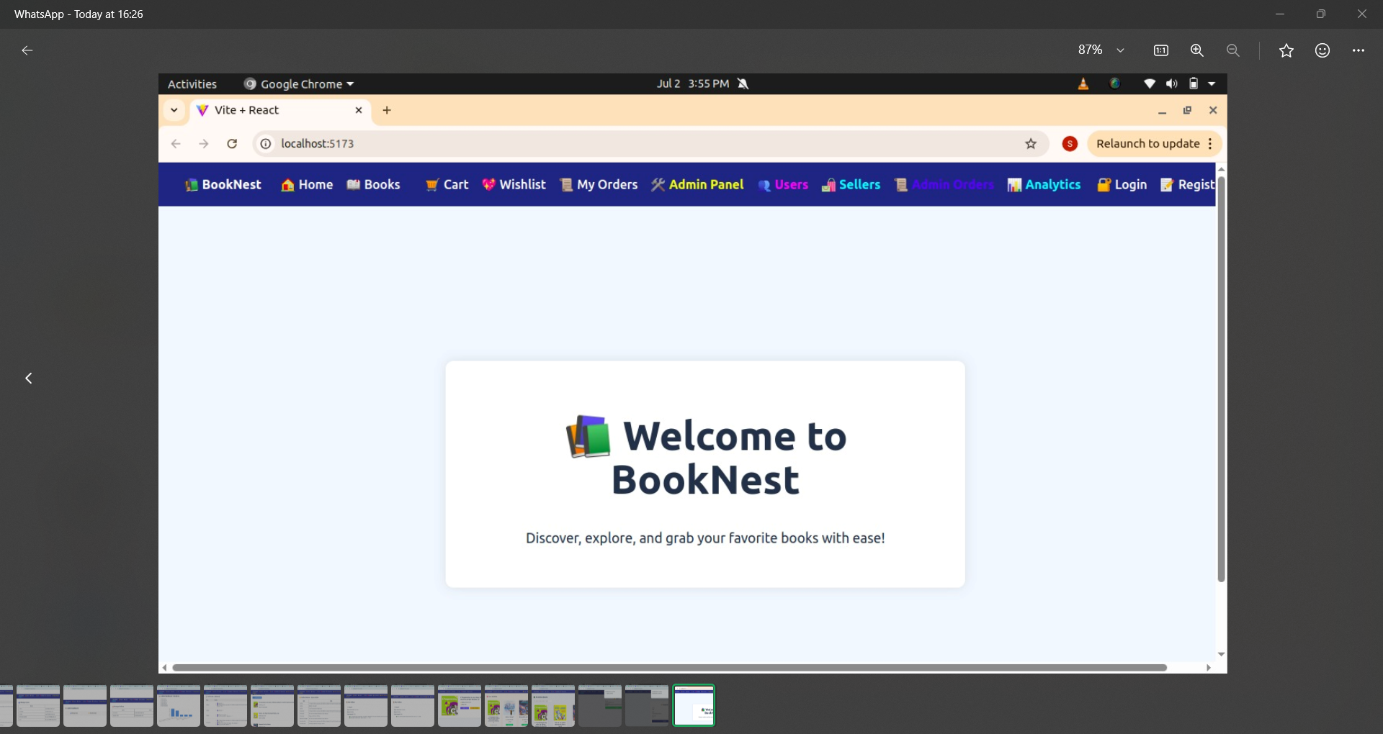

REGISTER PAGE:

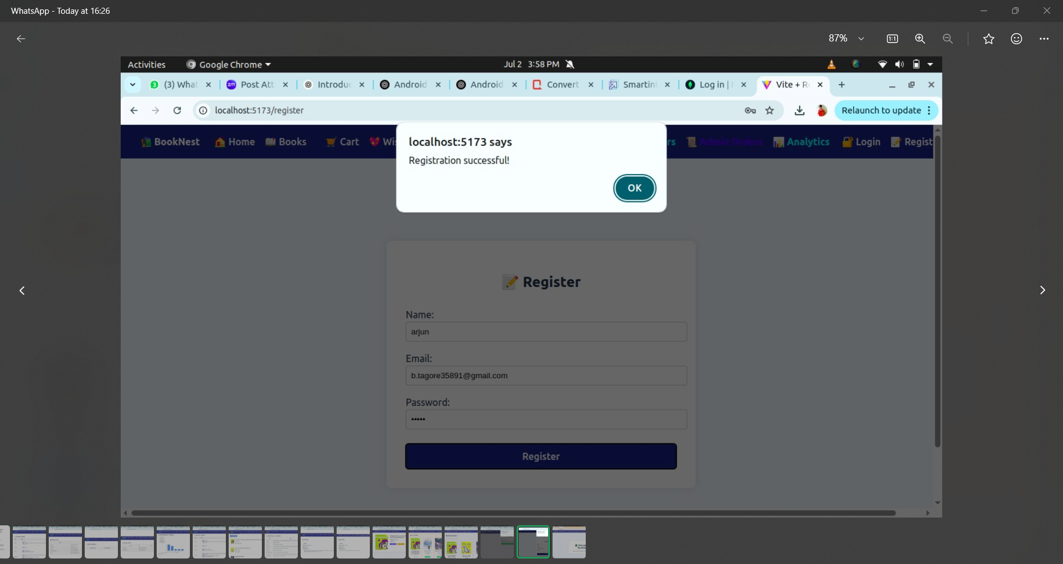

LOGIN PAGE:

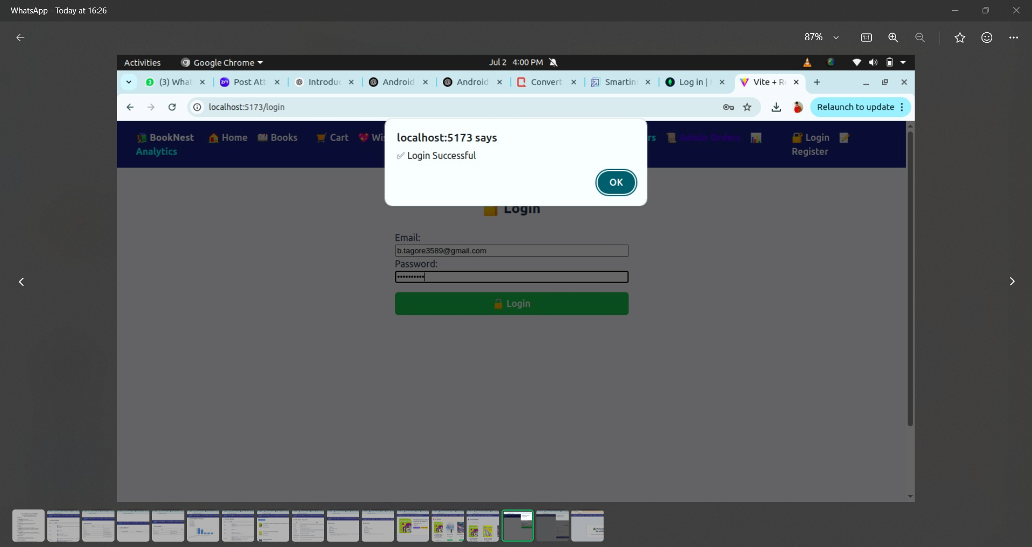

BOOKS PAGE:

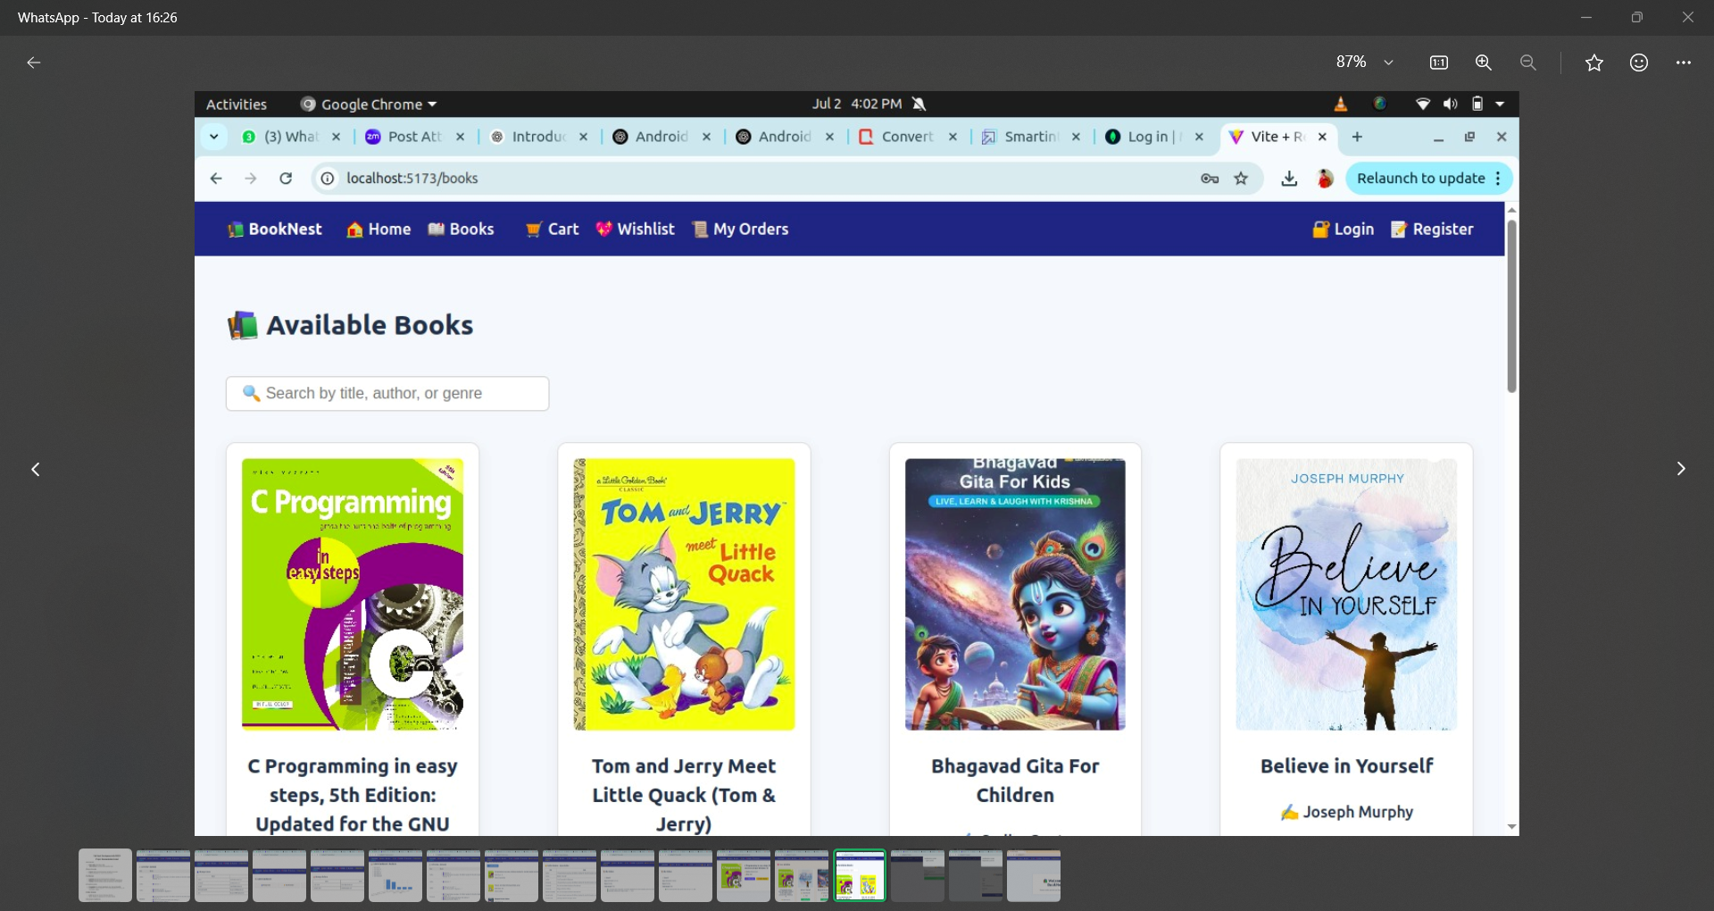

WISHLIST PAGE:

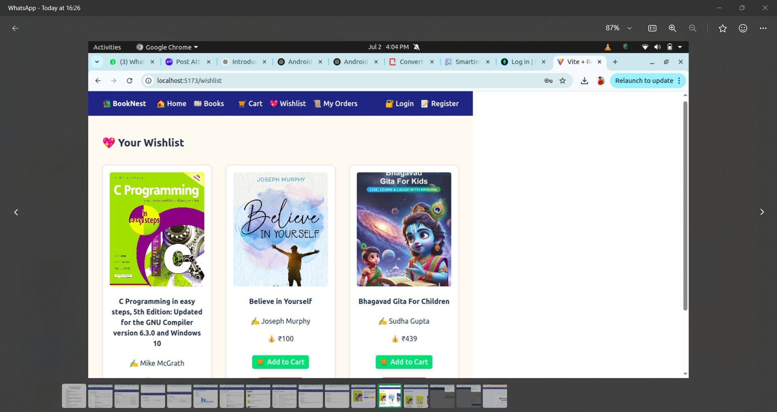

MY ORDERS :

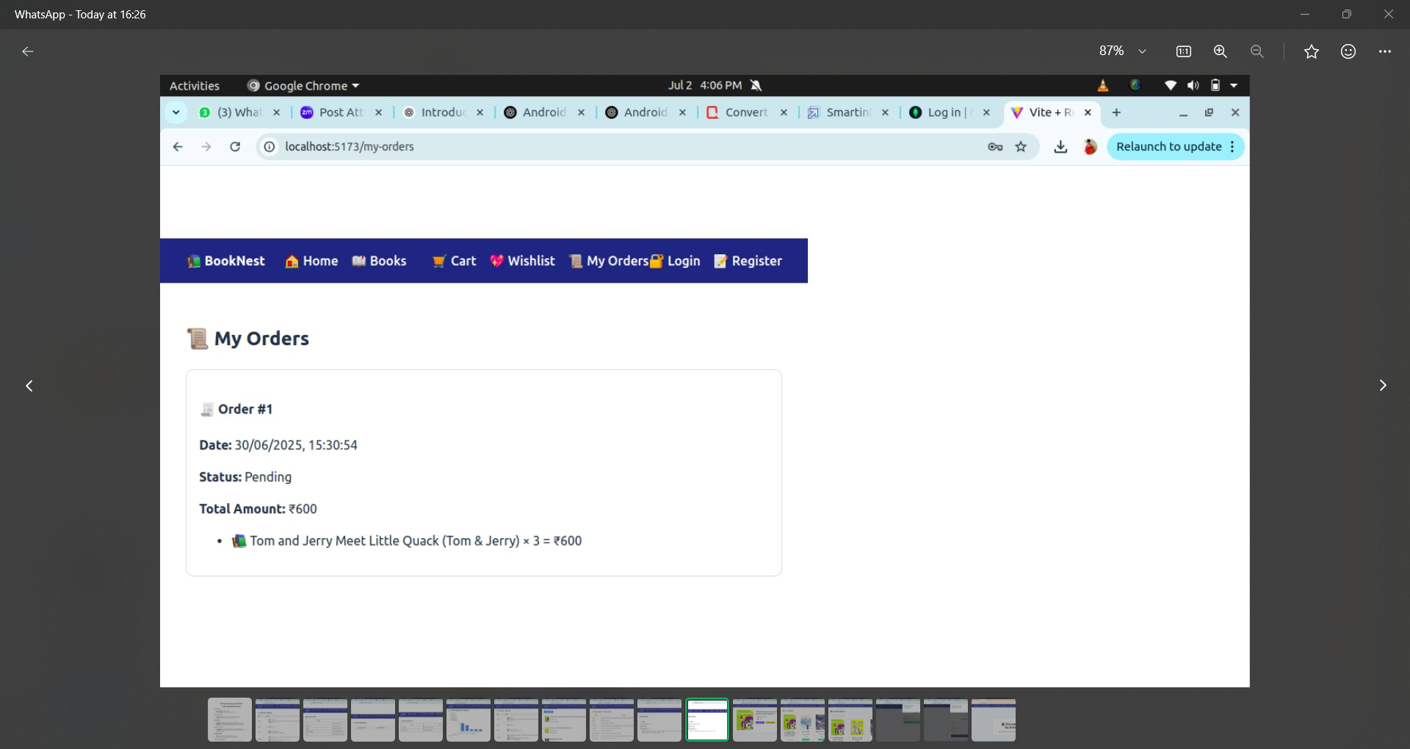

SELLER DASHBOARD:

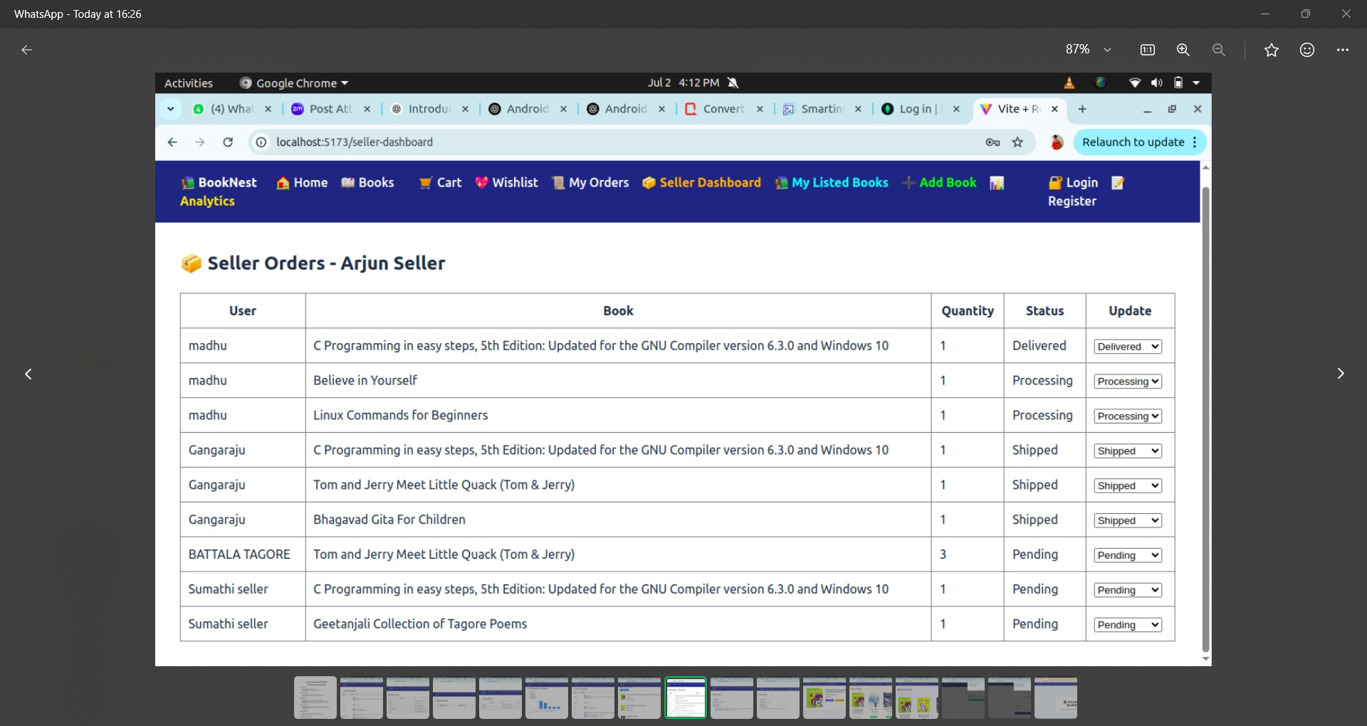

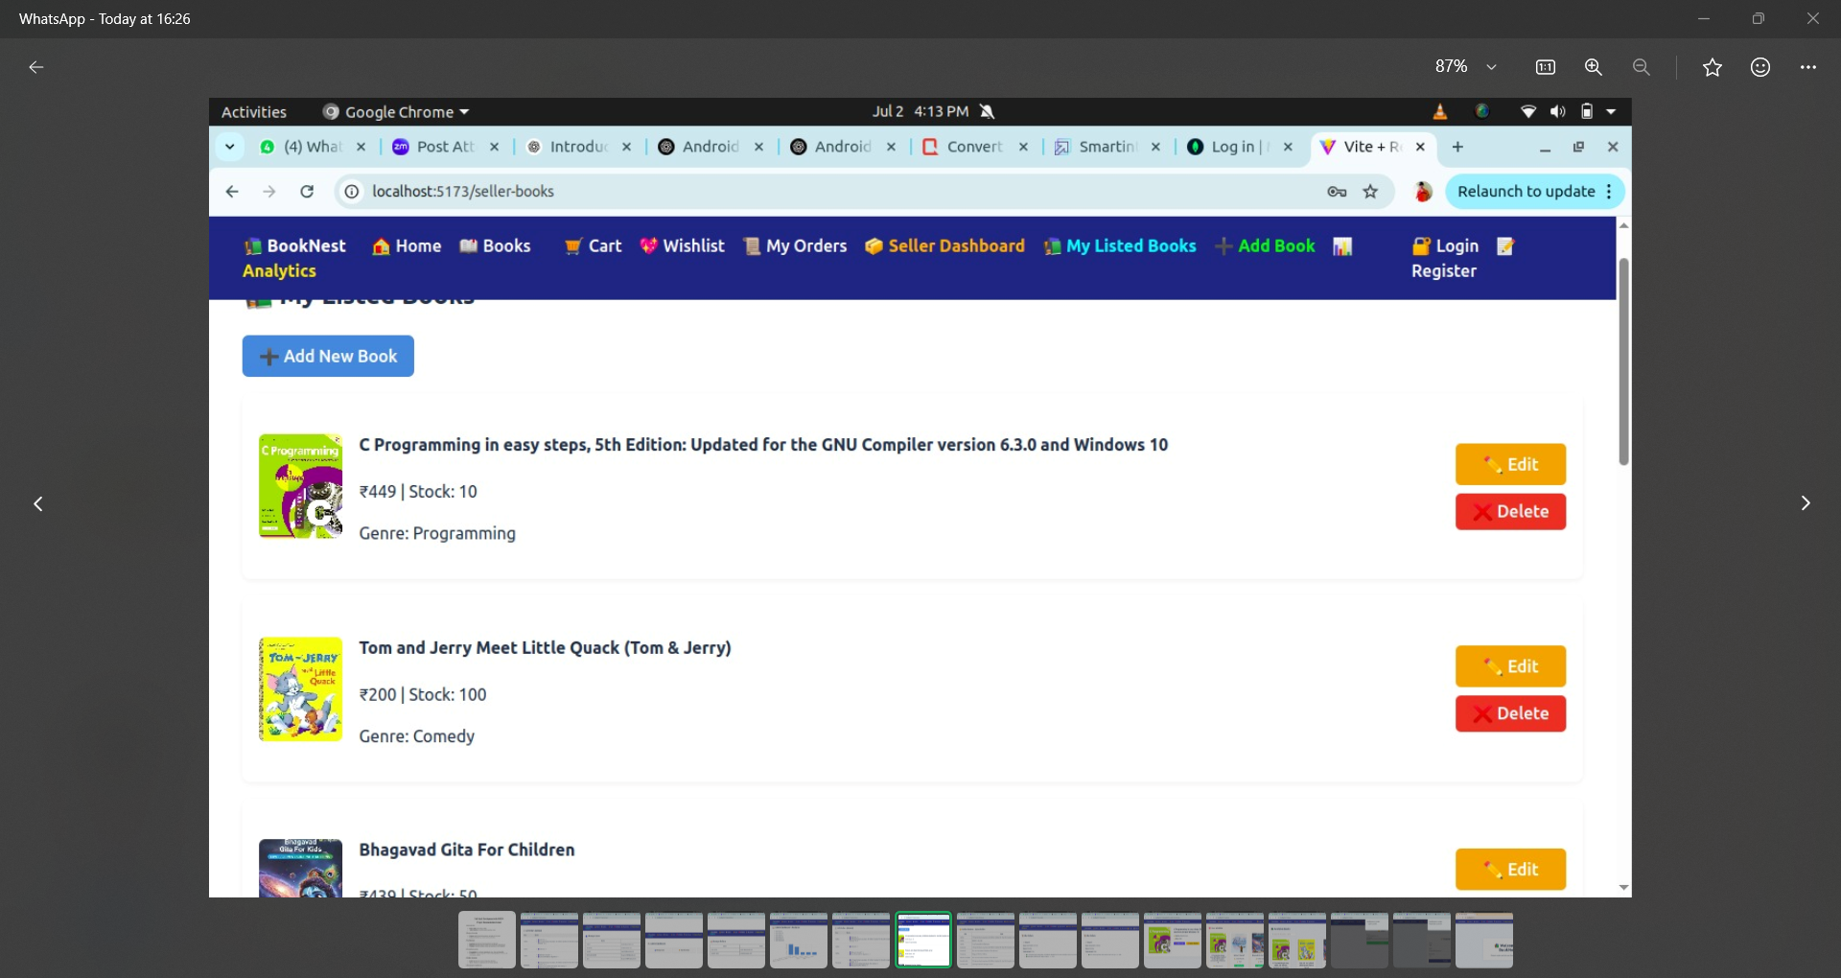

ADMIN DASHBOARD:

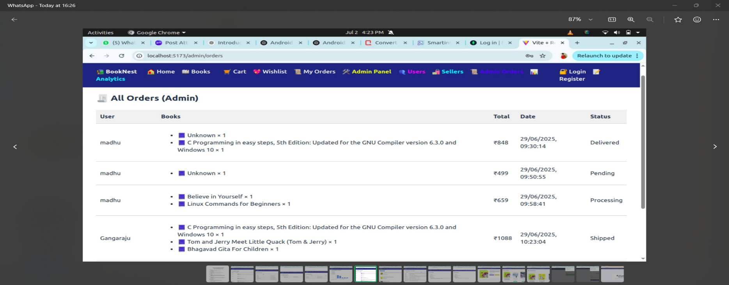

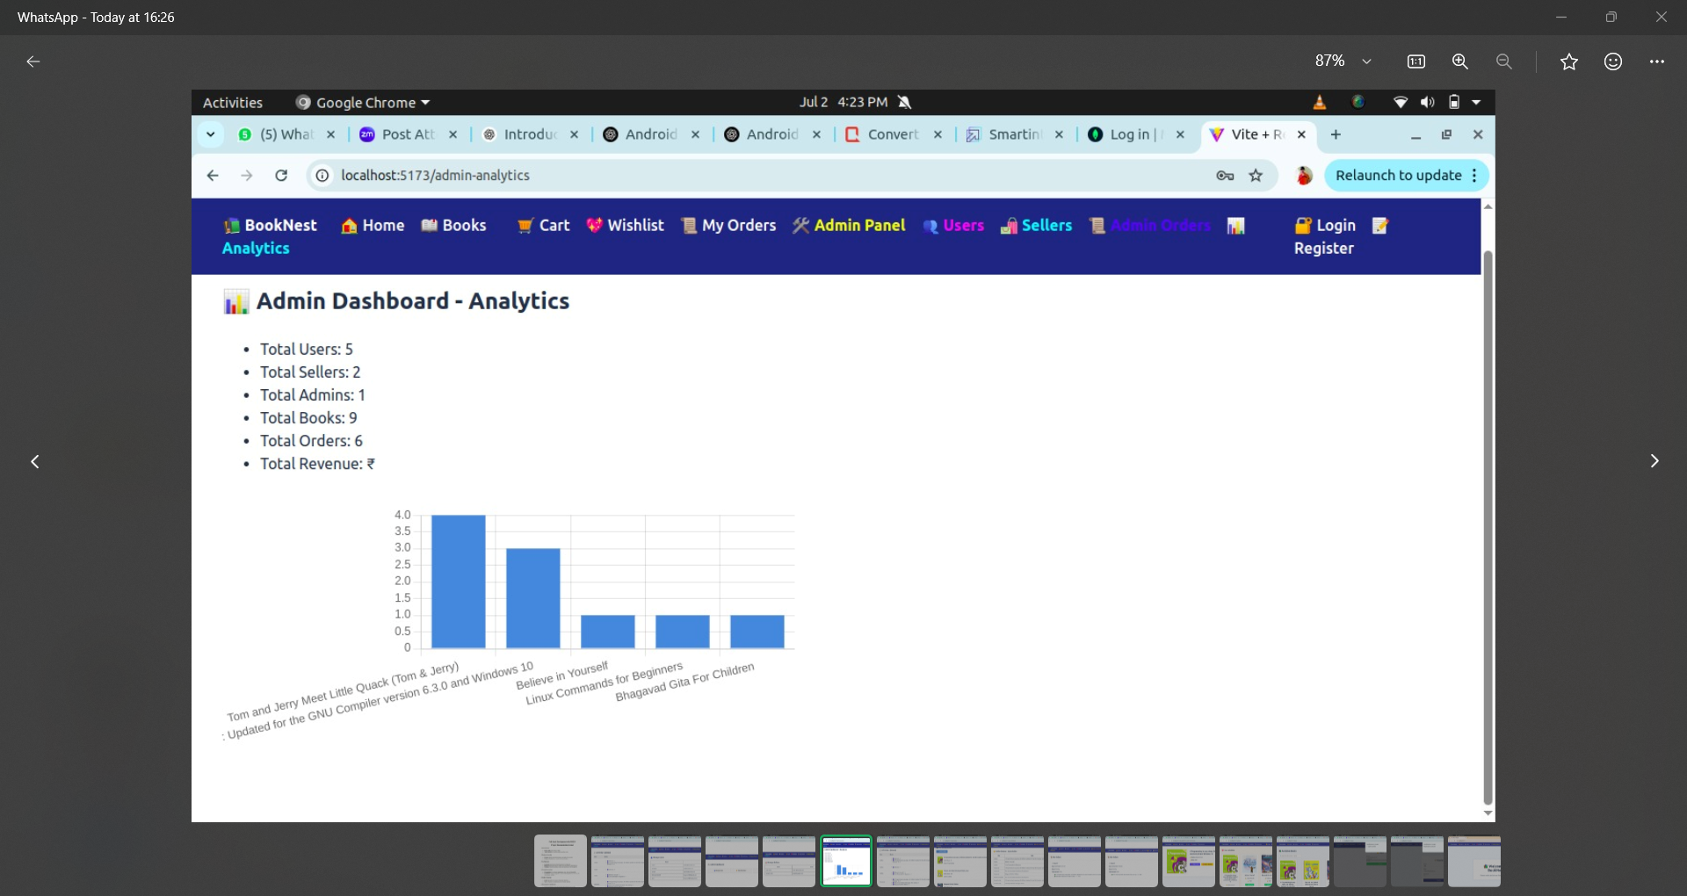

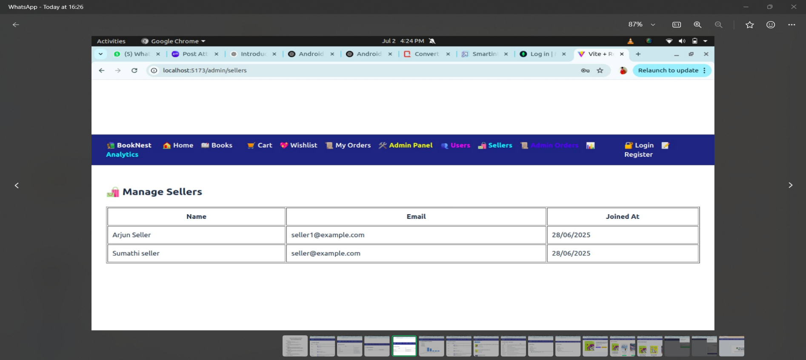

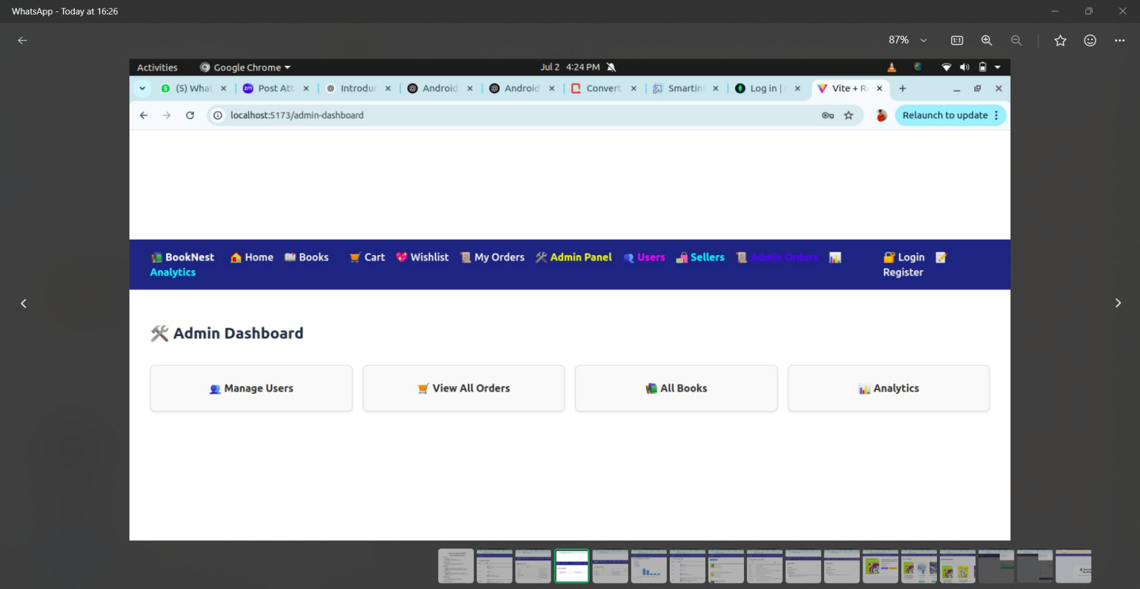

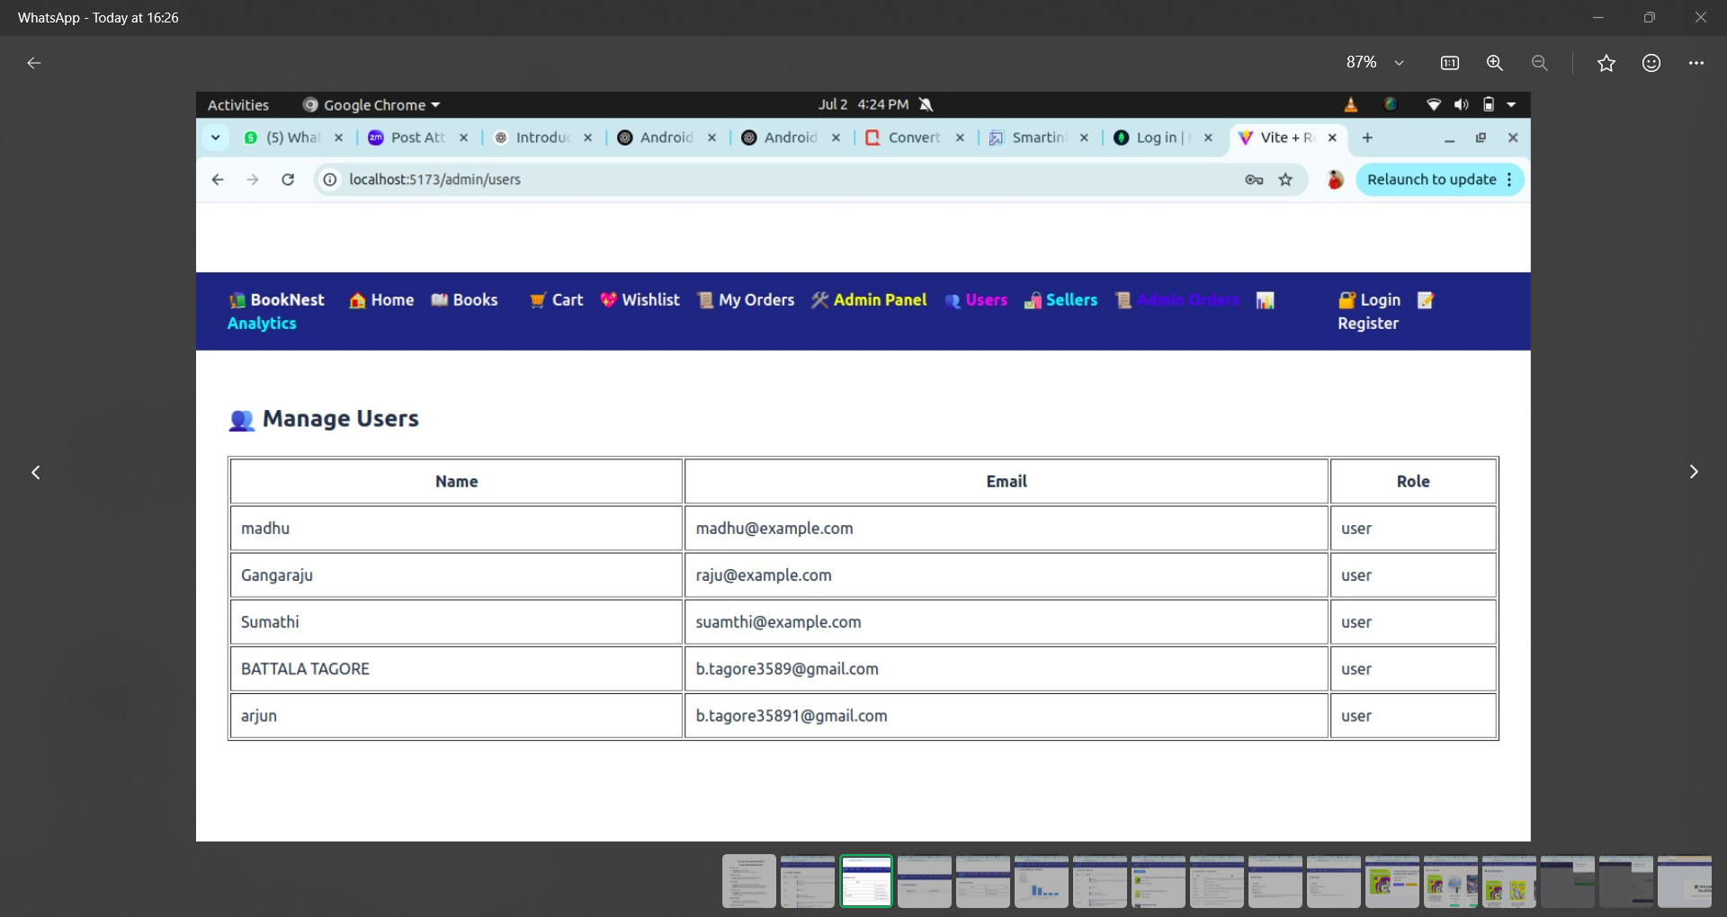

**11. Known Issues**

While the core functionality of **BookNest** is complete and stable, there are a few known limitations and bugs that can be addressed in future releases:

**⚠️ List of Known Issues:**

1. **No Email Verification:**
   * New users can register without email confirmation.
   * May allow spam/fake accounts.
2. **Limited Error Handling in Frontend:**
   * Some error messages are generic (e.g., "Something went wrong").
   * Needs better user-friendly feedback.
3. **Stock Validation is Client-Side Only:**
   * Book quantity isn't re-validated on the server before order placement.
4. **No Pagination or Search Filters:**
   * Large book lists are not paginated or filtered effectively.
   * Slower rendering for large datasets.
5. **No File Upload Handling:**
   * Book images must be provided as URLs; no image file upload feature.
6. **Basic Styling:**
   * Admin and Seller dashboards have basic designs, can be made more professional and interactive.
7. **Security Enhancements Needed:**
   * No rate limiting or CAPTCHA to prevent brute force login attempts.
   * Tokens are stored in localStorage (vulnerable to XSS).
8. **Order Cancellation and Return Features Missing:**
   * Users cannot cancel or return placed orders.

**12. Future Enhancements**

To make **Book Nest** more robust, scalable, and production-ready, the following improvements can be implemented:

**🚀 Functional Enhancements**

1. **Search, Filters, and Sorting:**
   * Add search by title/author
   * Filter by genre, price range, rating
   * Sort by price, popularity, etc.
2. **File Upload System:**
   * Integrate cloud storage (e.g., Cloudinary, AWS S3) for image uploads by sellers.
3. **Payment Gateway Integration:**
   * Integrate Razorpay or Stripe for real-time payment processing.
4. **Email Notifications:**
   * Send confirmation emails on registration, order placement, shipping updates.
5. **Order Cancellation & Refunds:**
   * Allow users to cancel orders and request refunds.

**🔐 Security Enhancements**

1. **Two-Factor Authentication (2FA)**
2. **Password Reset via Email**
3. **Rate Limiting and Captcha on Login**

**📱 UI/UX Improvements**

1. **Dark Mode**
2. **Better Dashboard Analytics (for Admin & Sellers)**
3. **Book Ratings Summary (Average Star Rating)**

**📊 Admin Features**

1. **Analytics Dashboard**
   * Sales tracking, top-selling books, user activity.
2. **User Reports**
   * Ability to suspend users/sellers based on complaints.